Target Operation with Water & Sound Effects

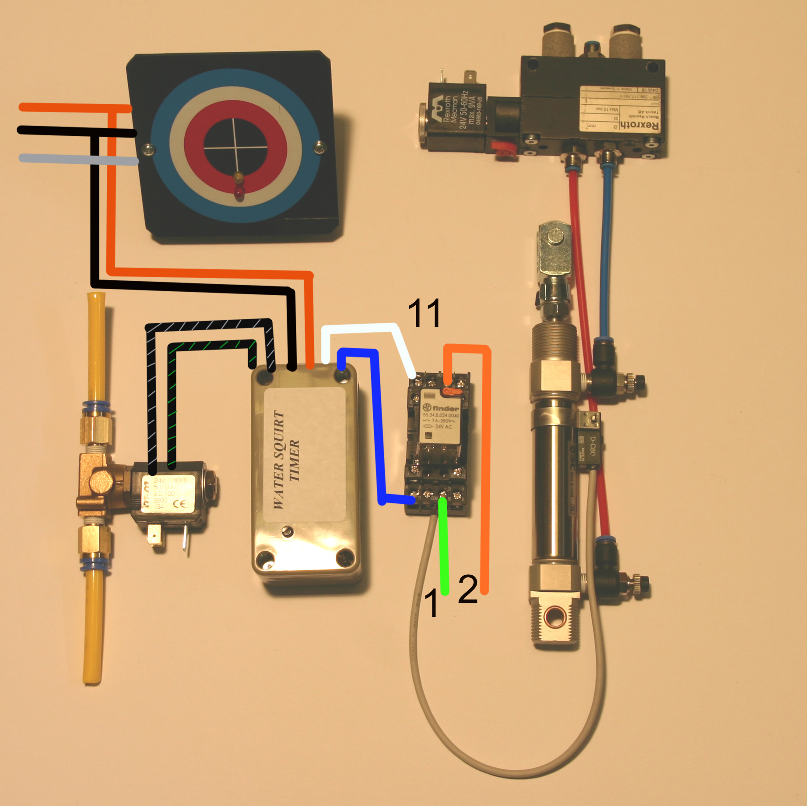
continued from sheet 2:-

Targets with both water and sounds require 2 outputs from the reed switch, this is achieved using a relay 11. The message repeater is switched by wires 1 & 2 (colours of the wires can vary).

sheet 3

